APPLYING FOR A TRUST EIN ONLINE THROUGH THE IRS
EIN for a Trust - applying for an EIN for a Revocable Trust

Q: Do you need a tax ID number for a trust?
A: Not always, but usually. There are some rare situations in which a tax ID number isn’t needed: A living revocable trust, for instance, may not need a tax ID number because it will instead use the beneficiary’s tax ID number.
Most trusts, however, do: If it isn’t a grantor trust or if there are more than two parties creating the trust, then it does need a separate tax ID number. A separate tax ID number is going to be necessary to pay taxes for the trust, open bank accounts for it, and cut checks from it: all of the basic activities that a trust has to complete in order to be active and useful.
Getting a tax ID number for a trust is a fairly simple process and should be done when the trust is opened so that the trust can take into possession the assets that it is designed to protect.

ACCESSING THE IRS APPLICATION AND APPLYING FOR THE EIN
After following the below steps and all validations are done you will get your EIN immediately upon completion. You can then download, save, and print your EIN confirmation notice.
-You may apply for an EIN online if your principal business is located in the United States or U.S. Territories.
-The person applying online must have a valid Taxpayer Identification Number (SSN, ITIN, EIN).
-You are limited to one EIN per responsible party per day.
-The “responsible party” is the individual (i.e., the natural person) who ultimately owns or controls the entity or who exercises ultimate effective control over the entity. Unless the applicant is a government entity, the responsible party must be an individual (i.e., a natural person), not an entity. The individual identified as the responsible party should have a level of control over, or entitlement to, the funds or assets in the entity that, as a practical matter, enables the individual, directly or indirectly, to control, manage, or direct the entity and the disposition of its funds and assets.
-You must complete this application in one session, as you will not be able to save and return at a later time.
-Your session will expire after 15 minutes of inactivity, and you will need to start over.

First go here to begin the online application process
https://www.irs.gov/businesses/small-businesses-self-employed/apply-for-an-employer-identification-number-ein-online

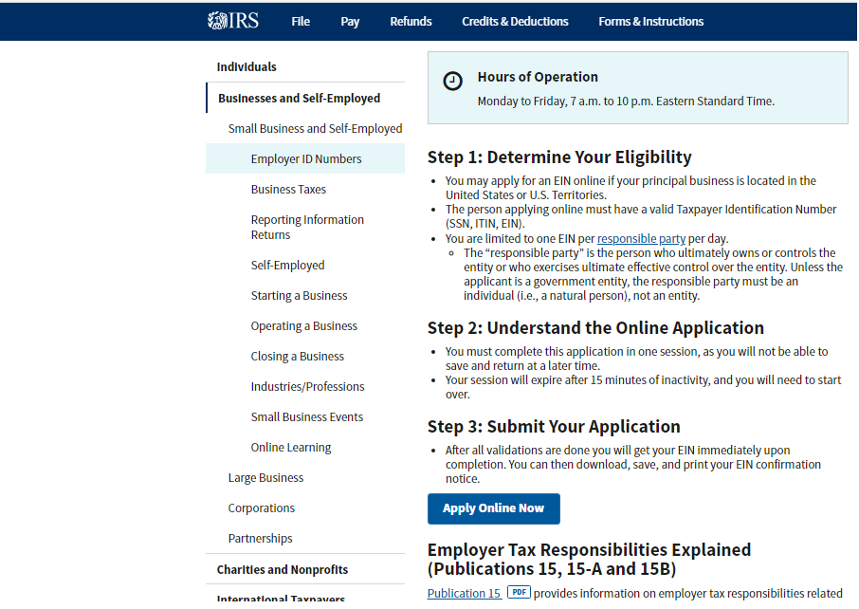
-Under the Step 3: Submit Your Application, click the "Apply Online Now" button

.

EIN Assistant Screen:
-Read the important information before you begin
-Click the ‘Begin Application’ button

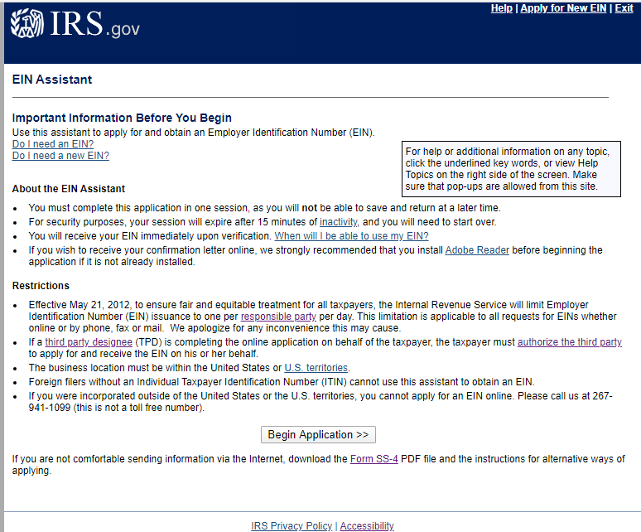

There are several EIN Assistant walk-through Progress Steps
The Progress Steps are:
- Identify
- Authenticate
- Addresses
- Details
- EIN Confirmation

What type of legal structure is applying for an EIN?
Before applying for an EIN you should have already determined what type of legal structure, business, or type of organization is being established.
The type of legal structure you are applying for is a Trust.
-In the list, select "Trust."
-click the ‘Continue’ button.

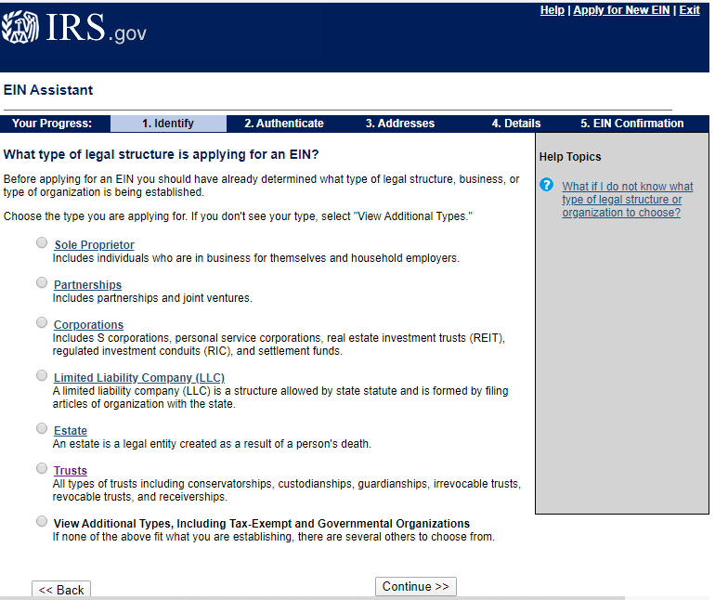

Identify the type of Trust.
You must identify one type of Trust you are applying for.
-select Revocable Trust from the list
-click the ‘Continue’ button.
(Revocable Trust: A revocable trust is a trust that may be altered or terminated during the grantor's lifetime. Since the trust may be altered at any time until the grantor's death, it is considered part of the grantor's estate and is subject to taxation. The property is passed on to the beneficiaries only after the grantor's death, and the revocable trust then becomes irrevocable.)
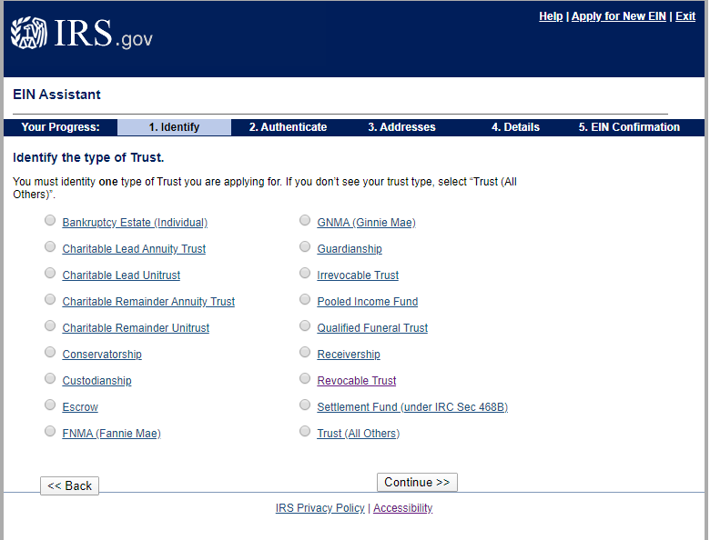

Please confirm your selection.
-Confirm your selection of Revocable Trust as the type of structure applying for an EIN
-click the ‘Continue’ button.

What it is...
A revocable trust is a trust in which the grantor retains the right to revoke and reclaim property that has been placed in the trust.
In a revocable trust, the grantor has control of the trust (power to repeal or annul) and will pay the taxes of the trust on Form 1040 (U.S. Individual Income Tax Return).
The grantor will also file Form 1041 (U.S. Income Tax Return for Estates and Trusts) for "information only" purposes.
If you need to change your type of structure, we recommend that you do so now, otherwise you will have to start over and re-enter your information. Additional help may be found by reviewing all types of organizations and structures before making your selection.

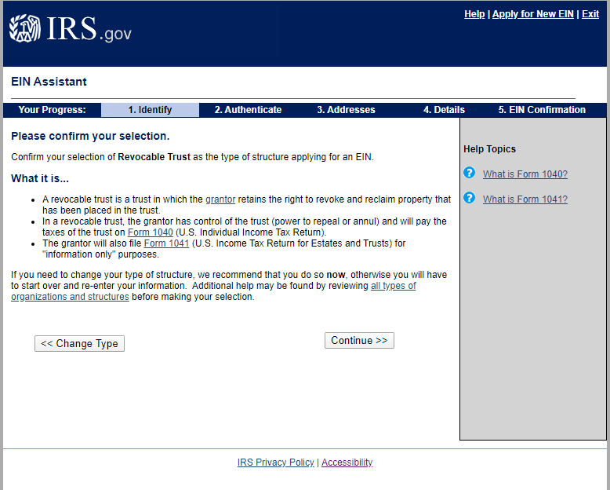

Please tell us about the Responsible Party.
-Fill in in the First name, Middle name/initial, Last name, Suffix (Jr, Sr., etc.) and SSN/ITIN
-leave the box UNCHECKED for “Trust filing as an Estate under Sec. 645”.
(Sec 645 applies to a deceased person's estate, and therefore does not apply for the purposes of the currency exchange and/or redemption.)
-Click the ‘Continue’ button

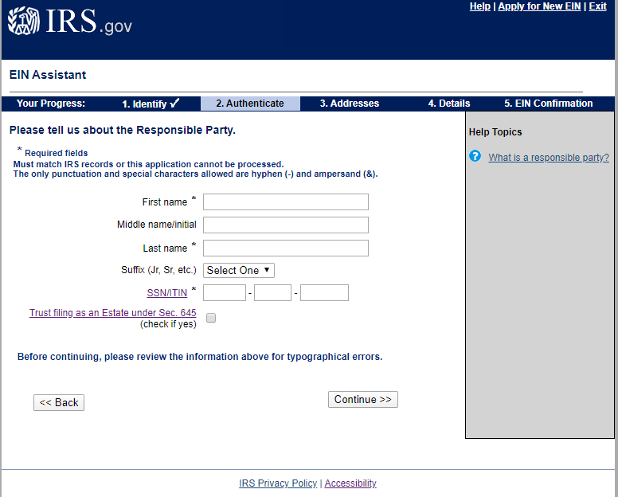

Please tell us about the Trustee.
-Fill in in the First name, Middle name/initial, Last name, Suffix (Jr, Sr., etc.) and SSN/ITIN
-Select “I am the grantor, trustee, or a beneficiary having a material interest for this trust”
-Click the ‘Continue’ button

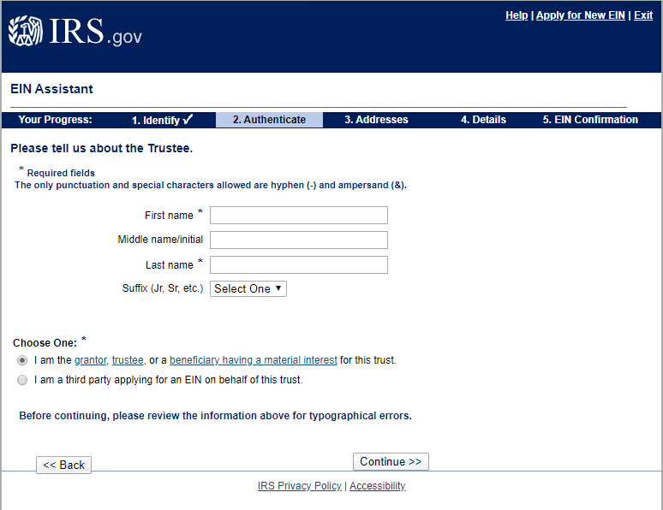

What is the Mailing Address for the Revocable Trust?
-Fill in the Street, City, State/Province/Territory, ZIP/Postal Code, Country, Phone Number
-Select Yes or No if you have a U.S. address that is different from the above?
-Click the ‘Continue’ button

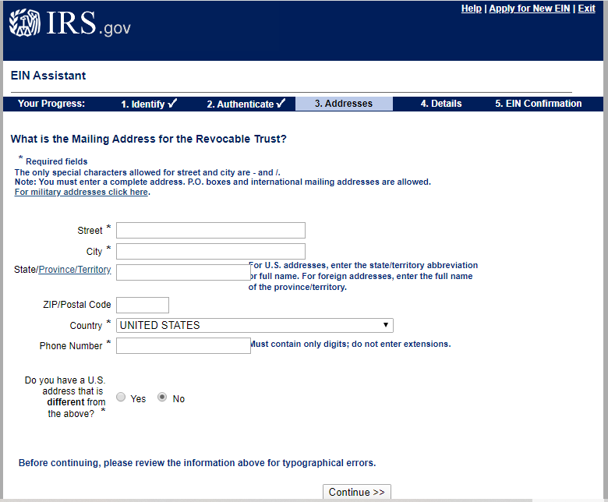

Tell us about the Revocable Trust.
The legal name may not contain any of the following endings: Corp, LLC, PLLC, LC, Inc, PA.

-Fill in
- Legal name of Revocable Trust
- County where Revocable Trust is located
- State/Territory where Revocable Trust is located
- Date Trust funded
- Year
- Closing month of accounting year

Be sure to read the Special instructions for entering the legal name of your trust

-Click the ‘Continue’ button
Please Note
Date Trust Funded. For a trust to become funded, title to the grantor's assets must be transferred into the trust. For example, title to any bank accounts, stock certificates, or real estate owned by the grantor must be transferred into the trust. The date this was done is the date the trust was funded.
Closing Month of Accounting Year: The closing month of the accounting year is the last month of your accounting year or tax year. An accounting or tax year is usually 12 consecutive months, based on either a calendar year or a fiscal year (including a period of 52 or 53 weeks).
A calendar year is 12 consecutive months ending on December 31. A fiscal year is either 12 consecutive months ending on the last day of any month (other than December) or a special 52-53 week year ending on a fixed day of the week (for example, the last Friday in March rather than March 31). For more information on accounting periods, see Pub.538.
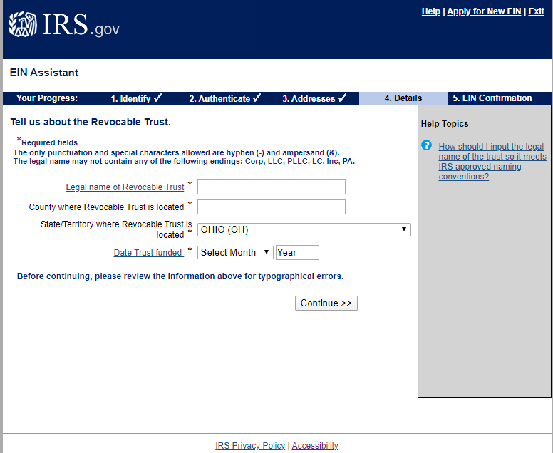

How would you like to receive your EIN Confirmation Letter?
-Select one:
- Receive letter online or
- Receive letter by mail
Note: if you select to ‘Receive letter online’ you will get your EIN immediately upon completion. You can then download, save, and print your EIN confirmation notice.
-Click the ‘Continue’ button

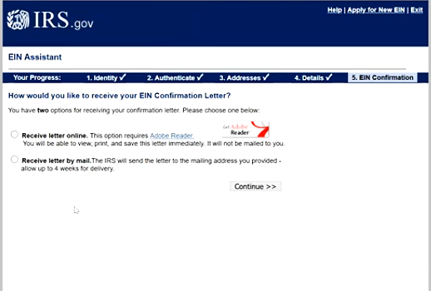

When will I be able to use my EIN?
This EIN is your permanent number and can be used immediately for most of your business needs, including:
- Opening a bank account
- Applying for business licenses
- Filing a tax return by mail.
However, it will take up to two weeks before your EIN becomes part of the IRS's permanent records. You must wait until this occurs before you can:
- File an electronic return
- Make an electronic payment
- Pass an IRS Taxpayer Identification Number matching program.

